讯为自带七寸屏

**1.扫描顺序如下：**

**屏幕接口：**

1. **内核lcd驱动目录：**driver/video/samsung

**3.内核配置：**Device Drivers --->

Graphics support --->

Support for frame buffer devices --->(不要去掉)

S5P Framebuffer support(测试时去掉)

Backlight & LCD device support --->(测试时去掉)

(Multimedia support --->它也会创建fb*设备节点还有 video*)

**4.本文件夹目录：**

lcd_testapp.c文件是在程序里读出bmp文件内容然后修改写入fb0;

make_image_for_4412.c文件是利用bmp图片制作出可以cat image > /dev/fb0的图片；

1. **lcd控制器时序图**

**上电时序：**

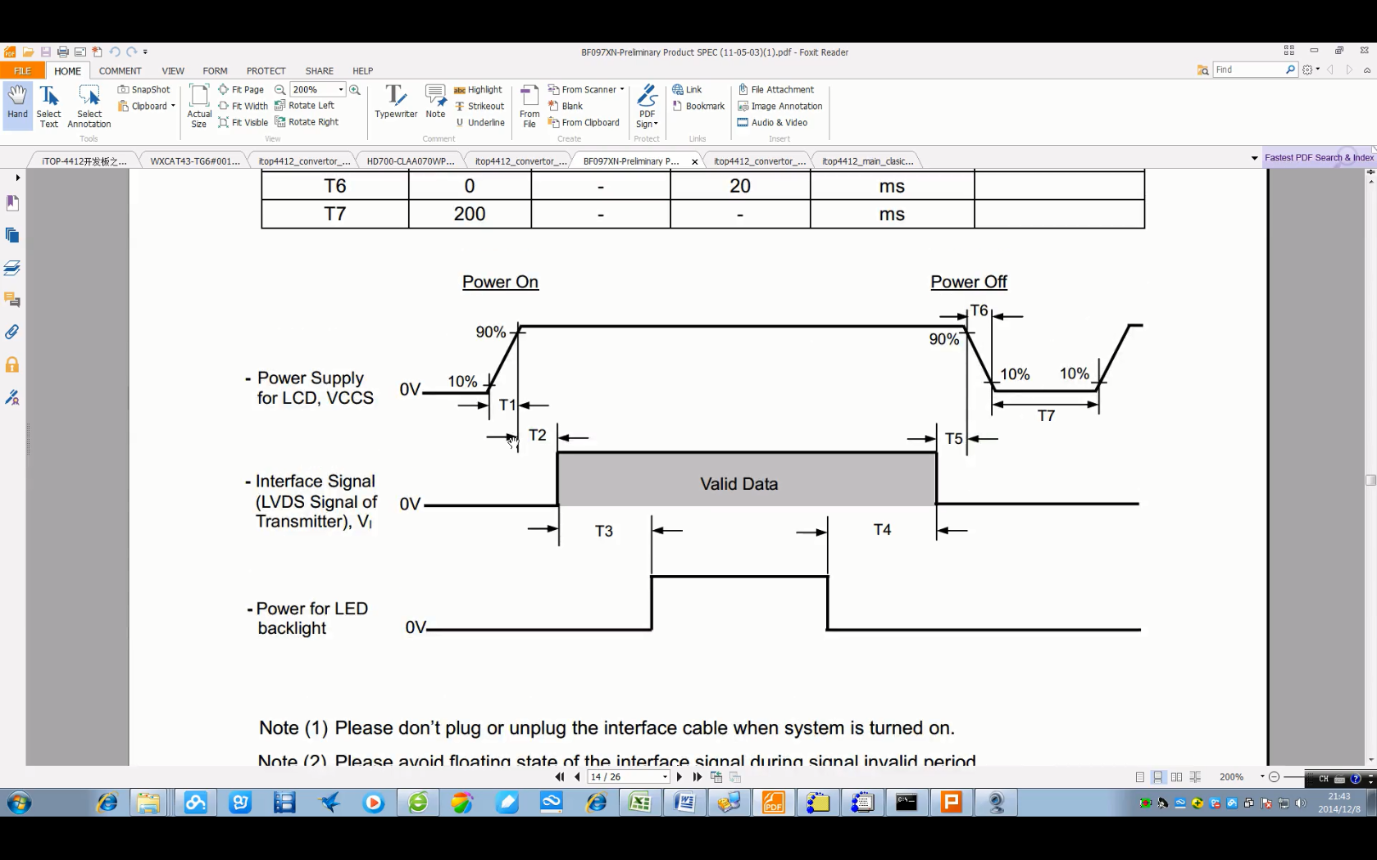

4412lcd控制器rgb输出时序：

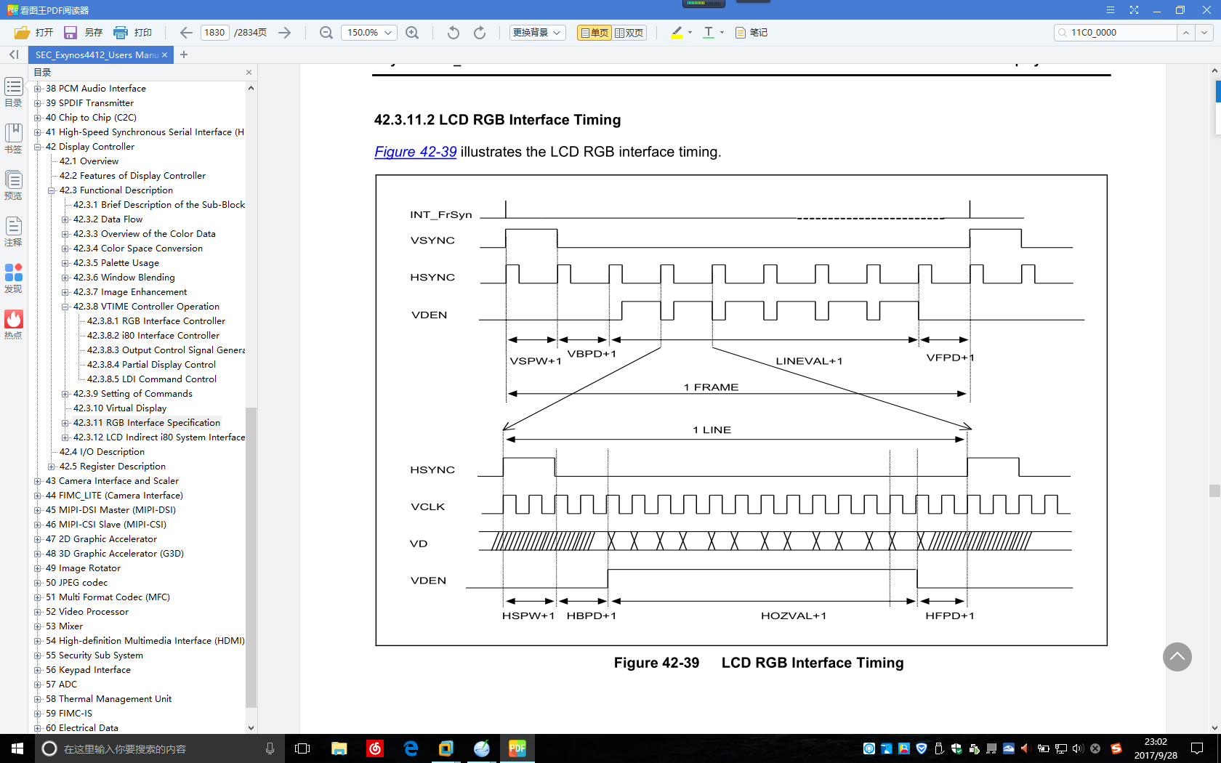

**屏幕数据手册：**

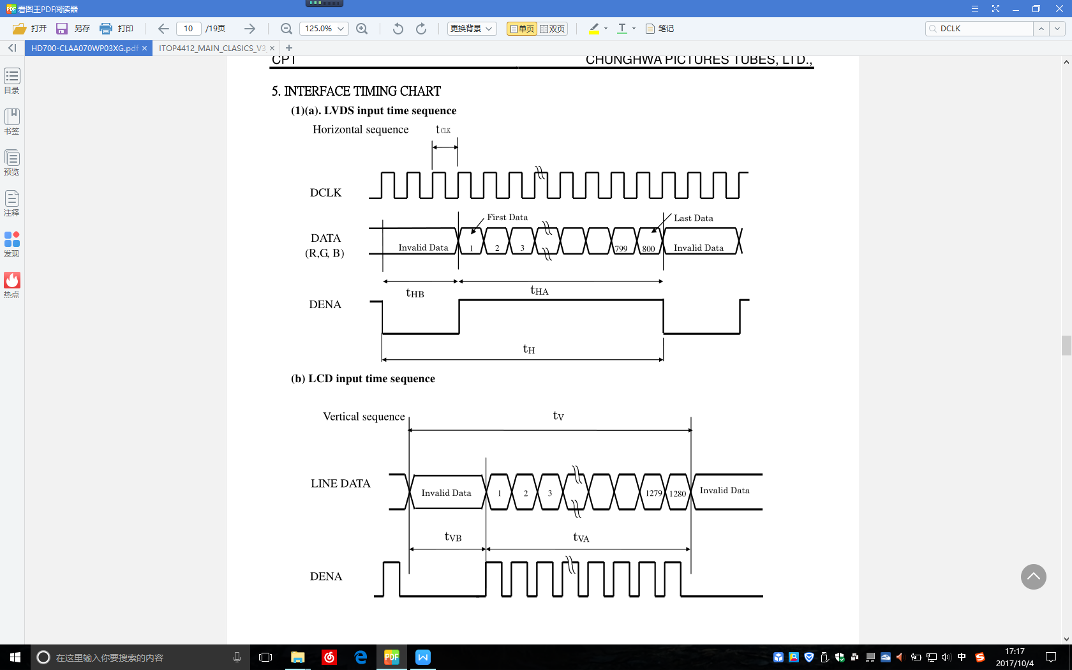

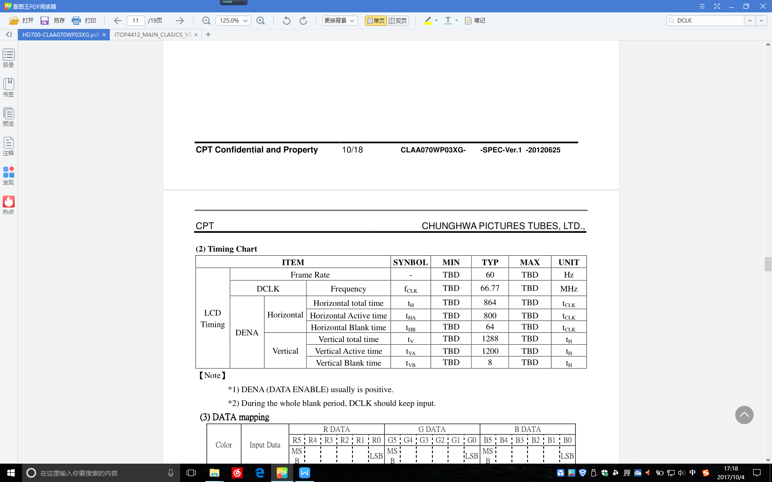

可以得出：HSPW:45 HBPD:35 HFPD:0

VSPW:12 VBPD:8 VFPD:0

极性方面：上升沿发数据

**6.内核中板子屏幕属性：**

static struct s3cfb_lcd wa101 = {

.bpp = 24,

.freq = 70

.timing = {

.h_fp = 48,

.h_bp = 80,

.h_sw = 32,

.v_fp = 3,

.v_fpe = 0,

.v_bp = 14,

.v_bpe = 0,

.v_sw = 5,

},

.polarity = {

.rise_vclk = 1,

.inv_hsync = 0,

.inv_vsync = 1,

.inv_vden = 0,

},

};

wa101.width = 800;

wa101.height = 1280;

wa101.bpp = 24;

wa101.freq = 50;

.hw_ver = 0x70,

.nr_wins = 5,

.swap = FB_SWAP_WORD | FB_SWAP_HWORD,

**7.讯为自带LCD驱动个人分析：**

1.lcd_regulator = regulator_get(NULL, "vdd33_lcd"); //从regulator_map_list表中找到对应名称 (vdd33_lcd)的regulator

2.regulator_enable(lcd_regulator); //使能该regulator

3.s3cfb_set_lcd_info(fbdev[i]); //fbdev[i]->lcd = &wa101;获取LCD信息

4.pdata->cfg_gpio(pdev); //初始化gpio

4.1初始化GPC0_2并且输出低电平 //其他LCD屏幕接口的MD_RSTN引角

msleep(250);

4.2初始化GPL0_4并且输出高电平 //即使能CHG_EN，产生VSYS_LCD电源

msleep(100);

4.3初始化GPF0_0至GPF3_3共28个引脚为lcd模式

4.4初始化GPL1_0并且输出高电平 //lvds的LCD_PWDN输出高点平

5.pdata->clk_on(pdev, &fbdev[i]->clock); //开启LCD模块,选择mpll时钟源,设置分 频，开启fimd时钟

6.res = platform_get_resource(pdev, IORESOURCE_MEM, i); //获取设备资源，此设备资源里 有lcd控制器的物理地址等。

1. s3cfb_init_global(fbdev[i]); //设置lcd控制器寄存器

7.1 s3cfb_set_output(fbdev); //设置输出模式

寄存器 位 值 意义

VIDCON0 bit[28:26] 0 OUTPUT_RGB

VIDCON2 bit[15] 0 WB_DISABLE

bit[14] 0

Bit[13:12] 0

7.2 s3cfb_set_display_mode(fbdev); //设置显示模式

寄存器 位 值 意义

VIDCON0 bit[19:17] 0 MODE_RGB_P

7.3 s3cfb_set_polarity(fbdev); //设置极性

寄存器 位 值 意义

VIDCON1 bit[10:9] 1 FIXVCLK_VCLK_RUN

Bit[7] 1 rise_vclk

Bit[5] 1 inv_vsync

7.4 s3cfb_set_timing(fbdev); //设置时序

寄存器 位 值 意义

VIDTCON0 bit[31:24] 0-1 VBPDE

bit[23:16] 14-1 VBPD

bit[15:8] 3-1 VFPD

bit[7:0] 5-1 VSPW

VIDTCON1 bit[31:24] 0-1 VFPDE

bit[23:16] 80-1 HBPD

bit[15:8] 48-1 HFPD

bit[7:0] 32-1 HSPW

7.5 s3cfb_set_lcd_size(fbdev); //设置lcd的分辨率

寄存器 位 值 意义

VIDTCON2 bit[10:0] 800-1 width

Bit[21:11] 1280-1 height

1. s3cfb_alloc_framebuffer(fbdev[i], i) //分配一个fb_info结构体

并且进行初始化

8.1 framebuffer_alloc(sizeof(struct s3cfb_window),fbdev->dev); //分配一个fb_info结构体

8.2 s3cfb_init_fbinfo(fbdev, i); //对fb_info进行初始化

strcpy(fix->id, “s3cfb”);

/* fbinfo */

fb->fbops = &s3cfb_ops;

fb->flags = FBINFO_FLAG_DEFAULT;

fb->pseudo_palette = &win->pseudo_pal

fix->xpanstep = 0;

fix->ypanstep = 0;

fix->type = FB_TYPE_PACKED_PIXELS;

fix->accel = FB_ACCEL_NONE;

fix->visual = FB_VISUAL_TRUECOLOR;

var->xres = lcd->width;

var->yres = lcd->height;

var->xres_virtual = var->xres;

var->yres_virtual = var->yres * CONFIG_FB_S5P_NR_BUFFERS;

var->bits_per_pixel = 32;

var->xoffset = 0;

var->yoffset = 0;

var->width = 0;

var->height = 0;

var->transp.length = 0;

fix->line_length = var->xres_virtual * var->bits_per_pixel / 8;

fix->smem_len = fix->line_length * var->yres_virtual;

var->nonstd = 0;

var->activate = FB_ACTIVATE_NOW;

var->vmode = FB_VMODE_NONINTERLACED;

var->hsync_len = timing->h_sw;

var->vsync_len = timing->v_sw;

var->left_margin = timing->h_bp;

var->right_margin = timing->h_fp;

var->upper_margin = timing->v_bp;

var->lower_margin = timing->v_fp;

var->pixclock = (lcd->freq *

(var->left_margin + var->right_margin

+ var->hsync_len + var->xres) *

(var->upper_margin + var->lower_margin

+ var->vsync_len + var->yres));

var->pixclock = KHZ2PICOS(var->pixclock/1000);

var->red.offset = 16;

var->red.length = 8;

var->green.offset = 8;

var->green.length = 8;

var->blue.offset = 0;

var->blue.length = 8;

var->transp.offset = 24;

var->transp.length = 8; /* added for LCD RGB32 */

8.3 s3cfb_map_default_video_memory(fbdev,fbdev->fb[i], fimd_id); //分配显存

1. s3cfb_register_framebuffer(fbdev[i]) //注册一个framebuffer
2. s3cfb_set_clock(fbdev[i]); //

寄存器 位 值 意义

VIDCON0 bit[16] 0

bit[5] 0

bit[13:6] 15 CLKVAL_F

1. s3cfb_enable_window(fbdev[0], pdata->default_win);

s3cfb_window_on(fbdev, id);

寄存器 位 值 意义

SHADOWCON 0 1 Enables Channel 0

WINCON0 0 1 Enables the video output and video control signal

1. s3cfb_display_on(fbdev[i]);

寄存器 位 值 意义

VIDCON0 bit[1:0] 3 开启LCD控制器

1. register_early_suspend(&fbdev[i]->early_suspend);
2. pdata->backlight_on(pdev); //使能背光灯

mdelay(250);

GPD0_1初始化并输出高电平

mdelay(5);

GPC0_2初始化并输出高电平

1. pdata->lcd_on(pdev); //空的